Jenkins challenges
- Create one Declarative pipeline job
Source Code:https://github.com/betawins/hiring-app.git
- Repository contains the application code for the hiring app.
Open the Jenkins dashboard and navigate to the "New Item" section to initiate the process. Select "Pipeline"

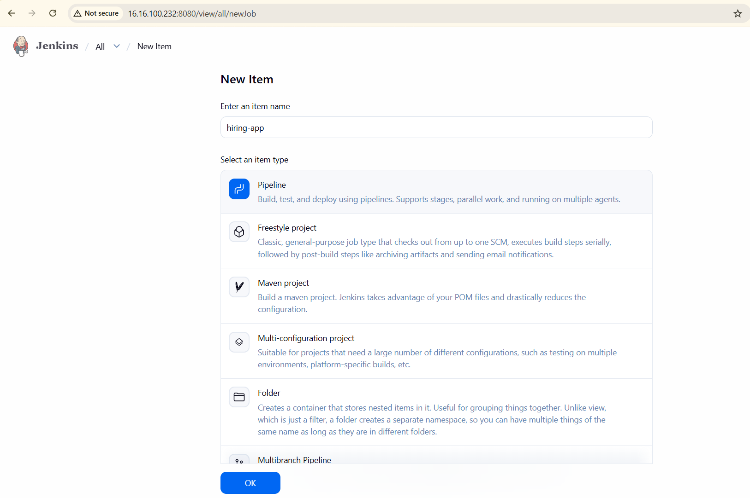
And go to soanrqube configuration settings and click on the reposotory
Create a new repository-->select maven hosted 2-->name it hiring-app-2-->select the version policy-->snapshot-->give layout policy as "permissive”-->deployment policy as "allow redeploy" and click "create repository". Once configured, navigate to the Jenkins pipeline script section to define the build stages.
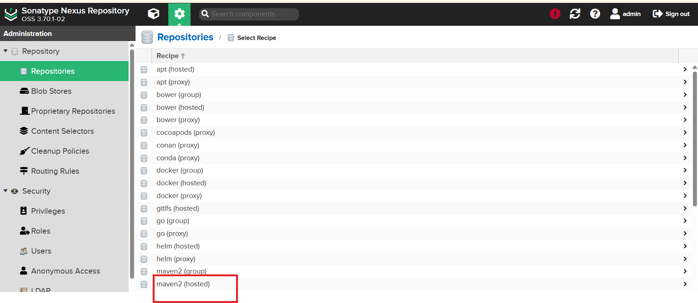
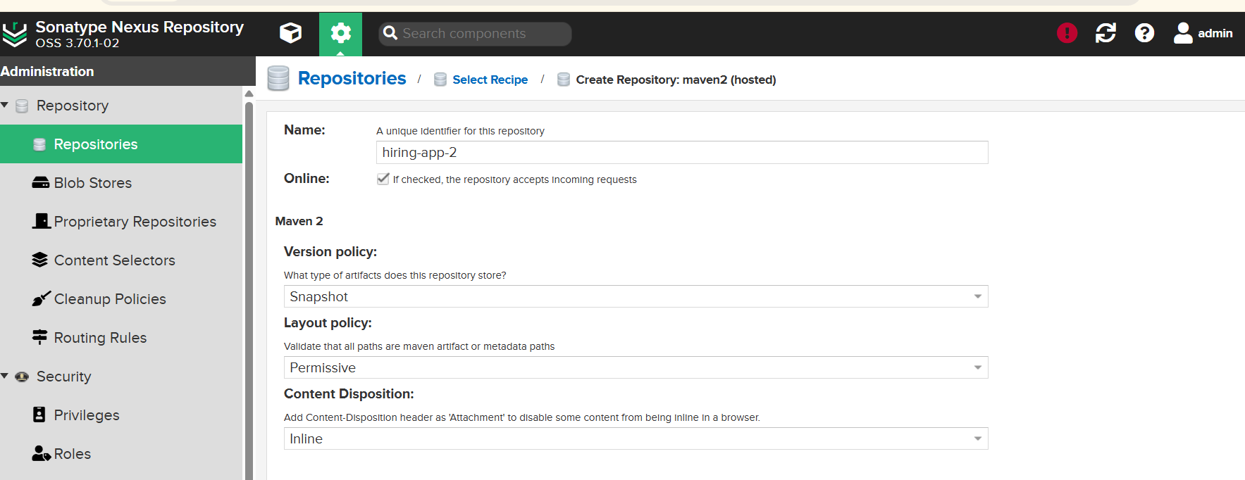

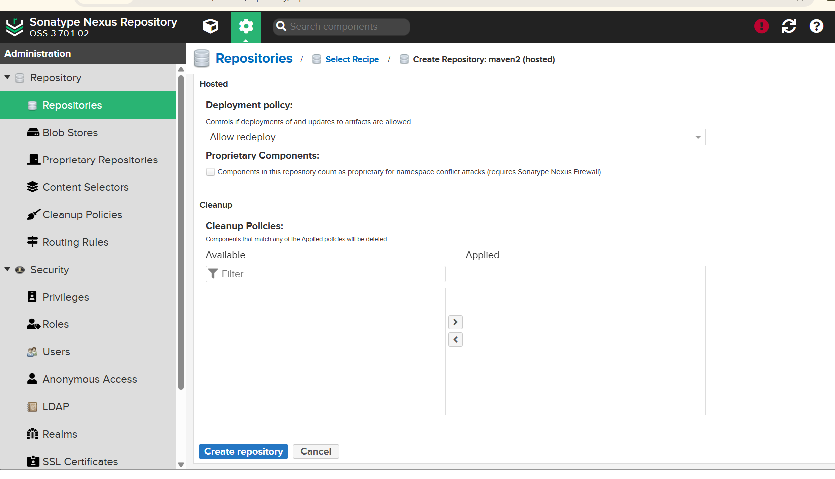
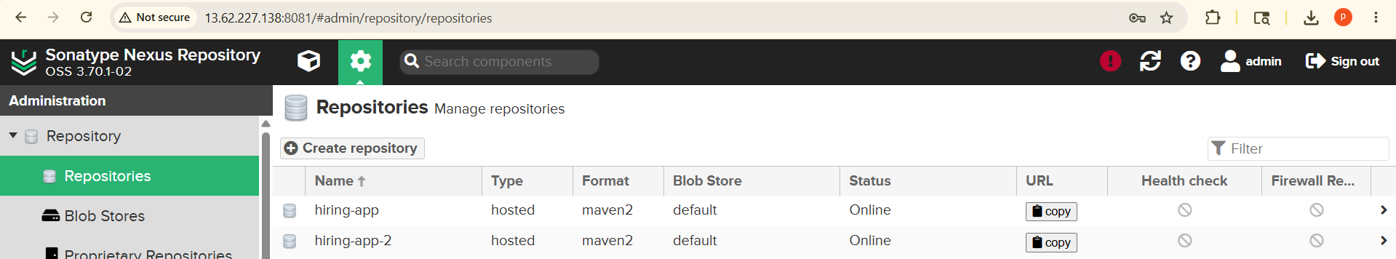
Successfully created repository then go back to the Jenkins dashboard to configure the pipeline script. Within the pipeline definition, specify the stages for checkout, build, and SonarQube analysis, ensuring the environment variables are correctly mapped to your newly created repository. Once the script is finalized, save the configuration and trigger the build process to verify that the artifacts are successfully deployed to the Maven repository, completing the integration pipeline.Upon successful execution, inspect the Jenkins console output to confirm that all stages have completed without errors. If the build fails, review the logs to identify potential misconfigurations in the credentials or network settings. Once verified,
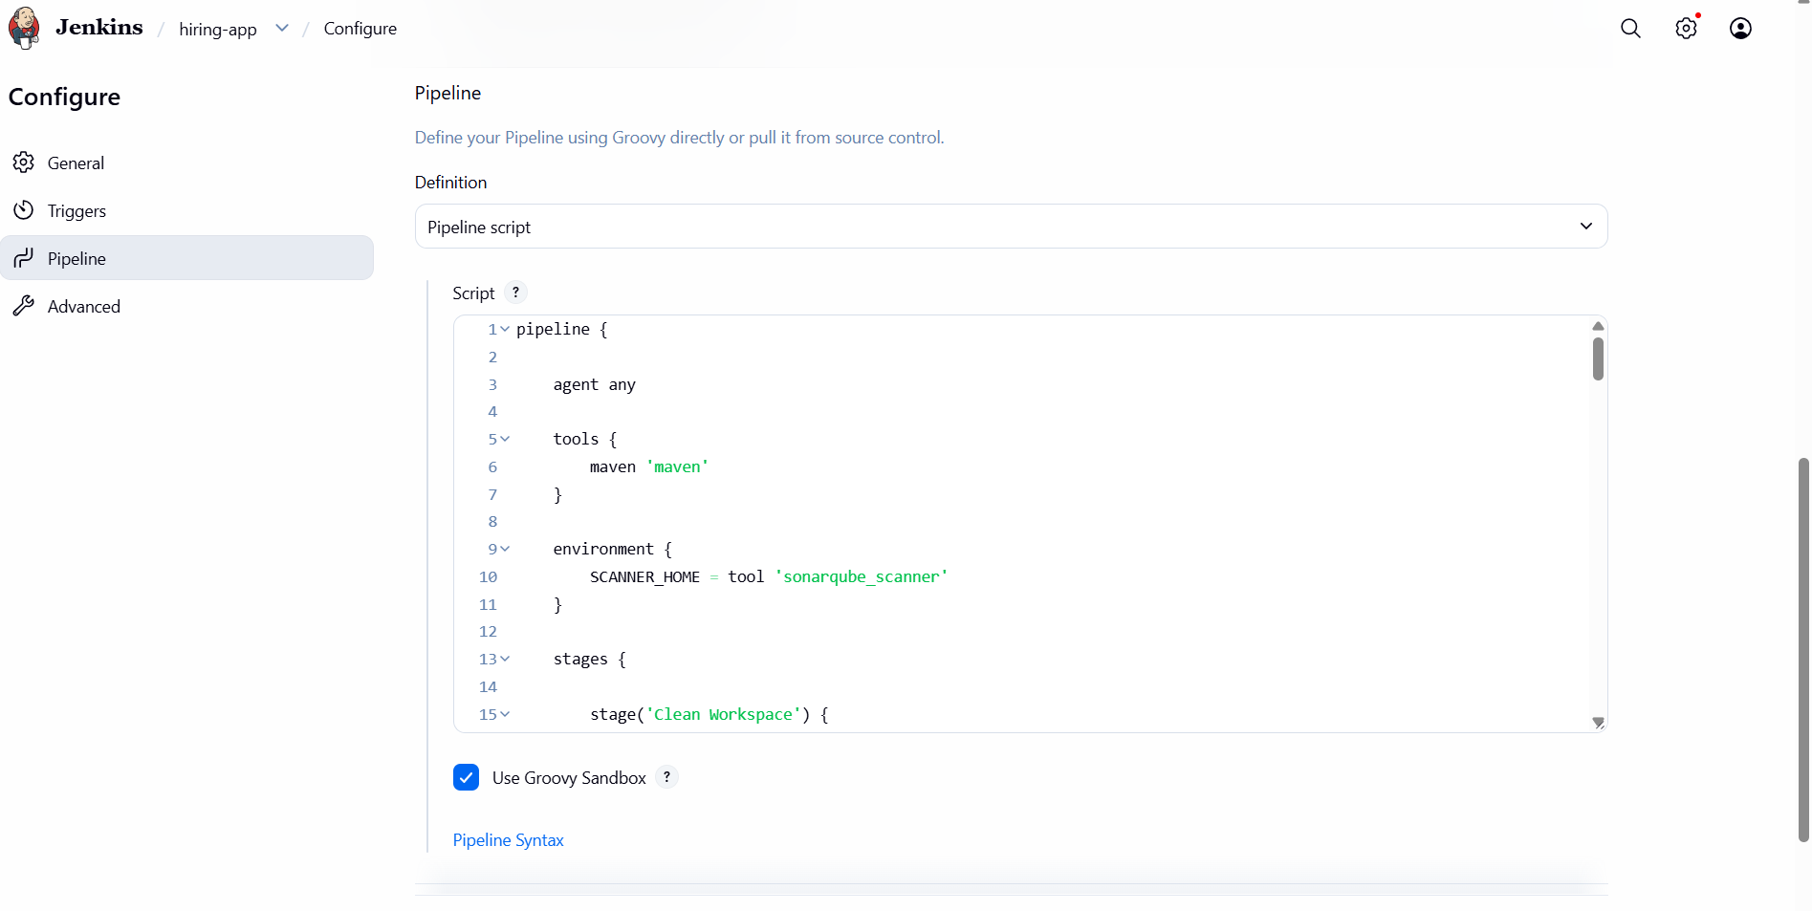
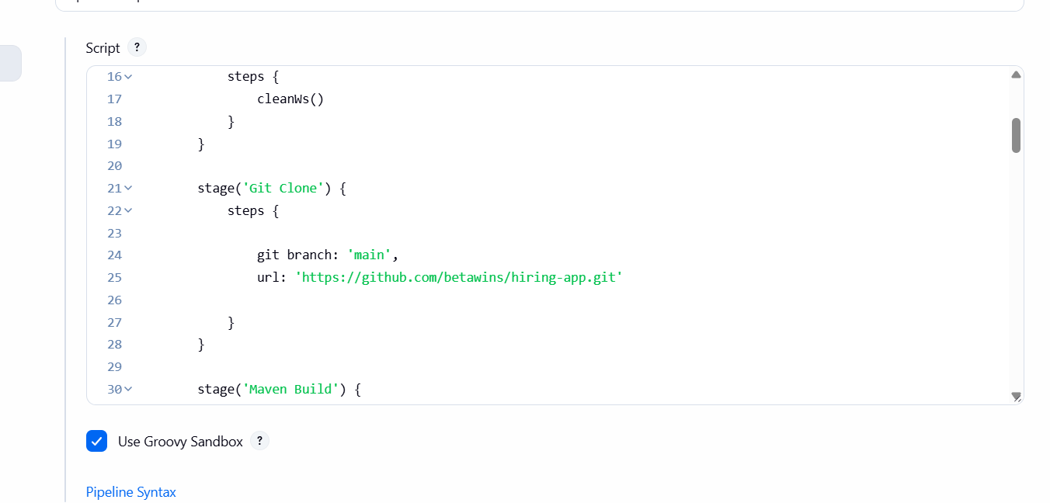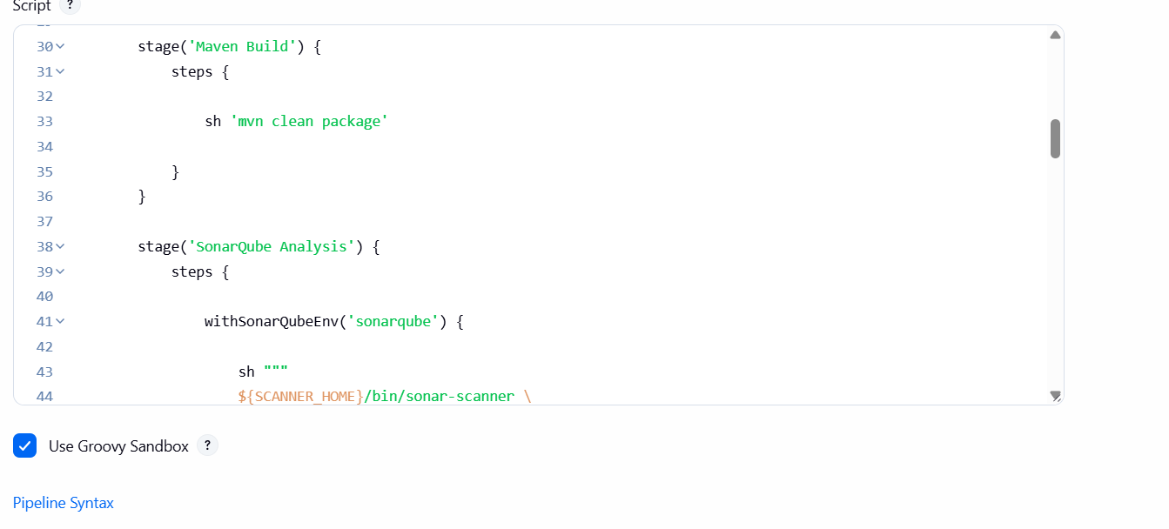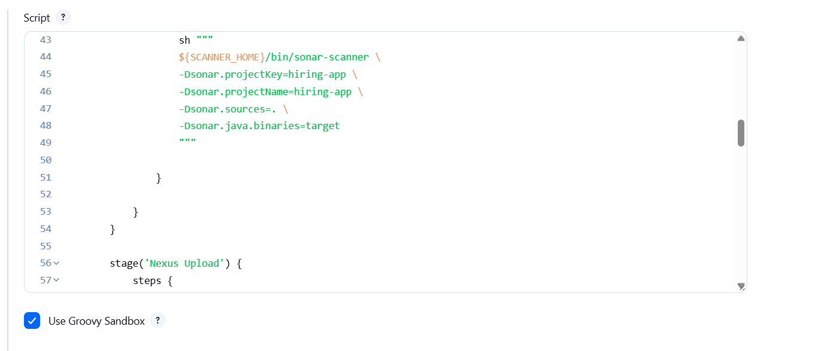
Groupid and version, is taken by the hirinhg repository and
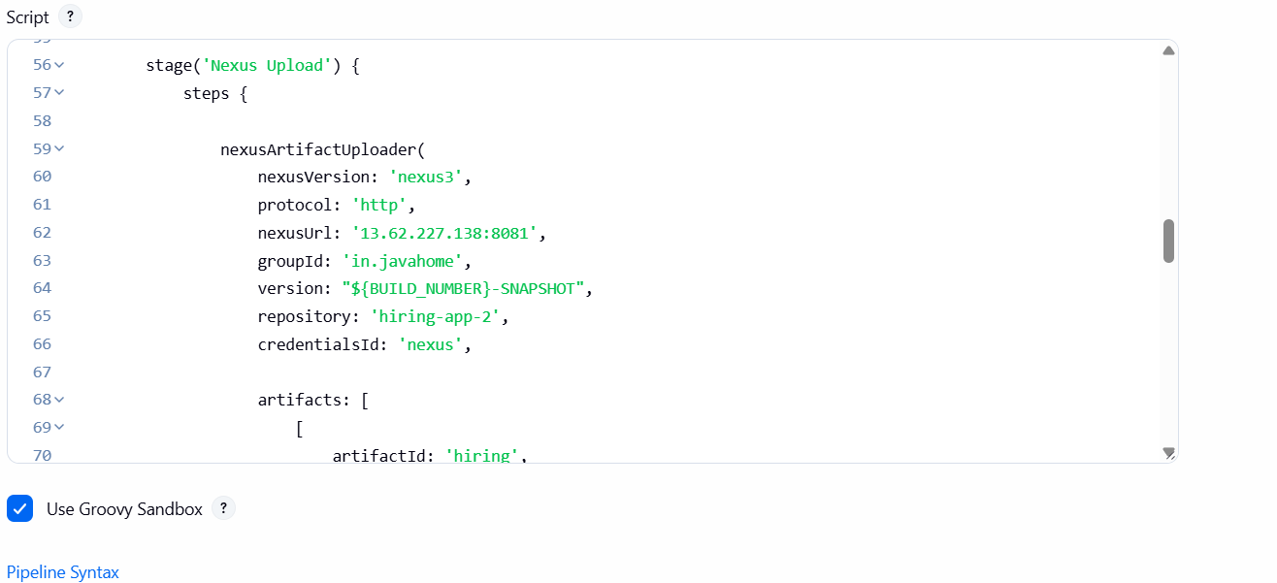
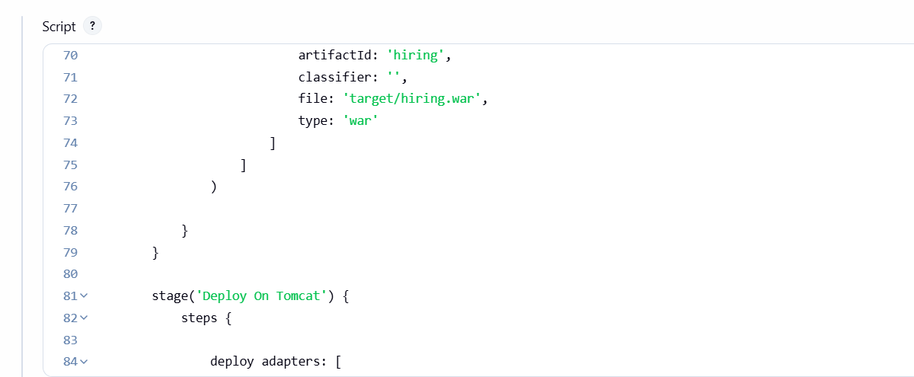
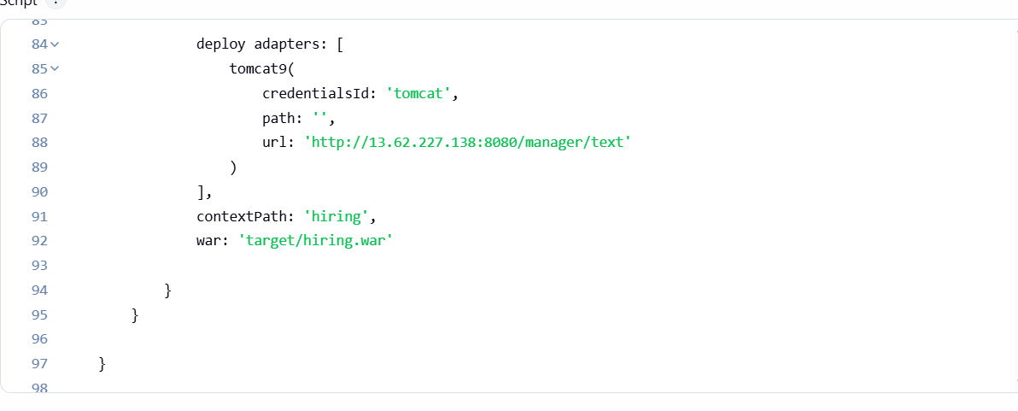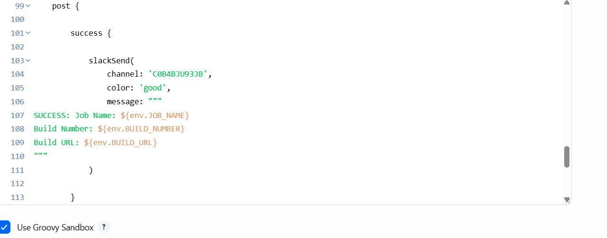
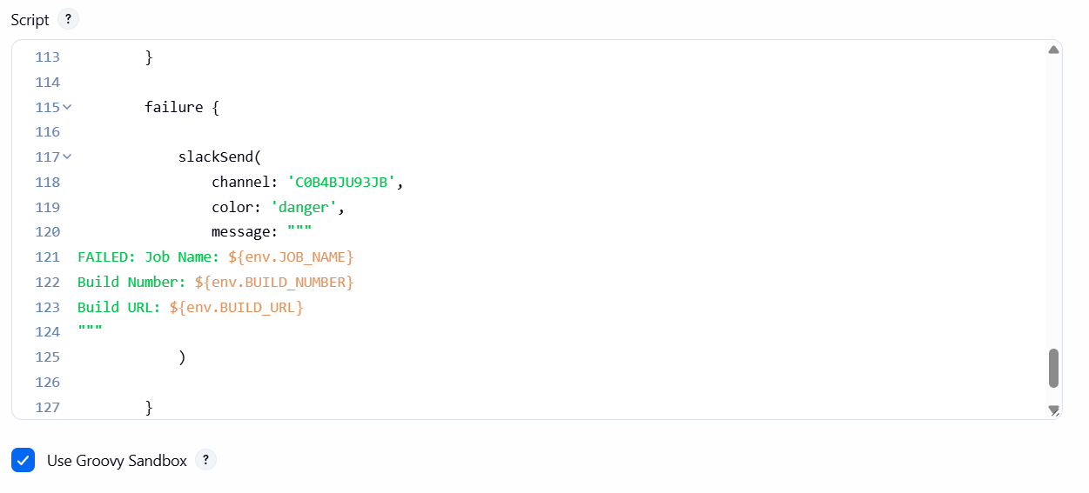
Script is completed after that click on build
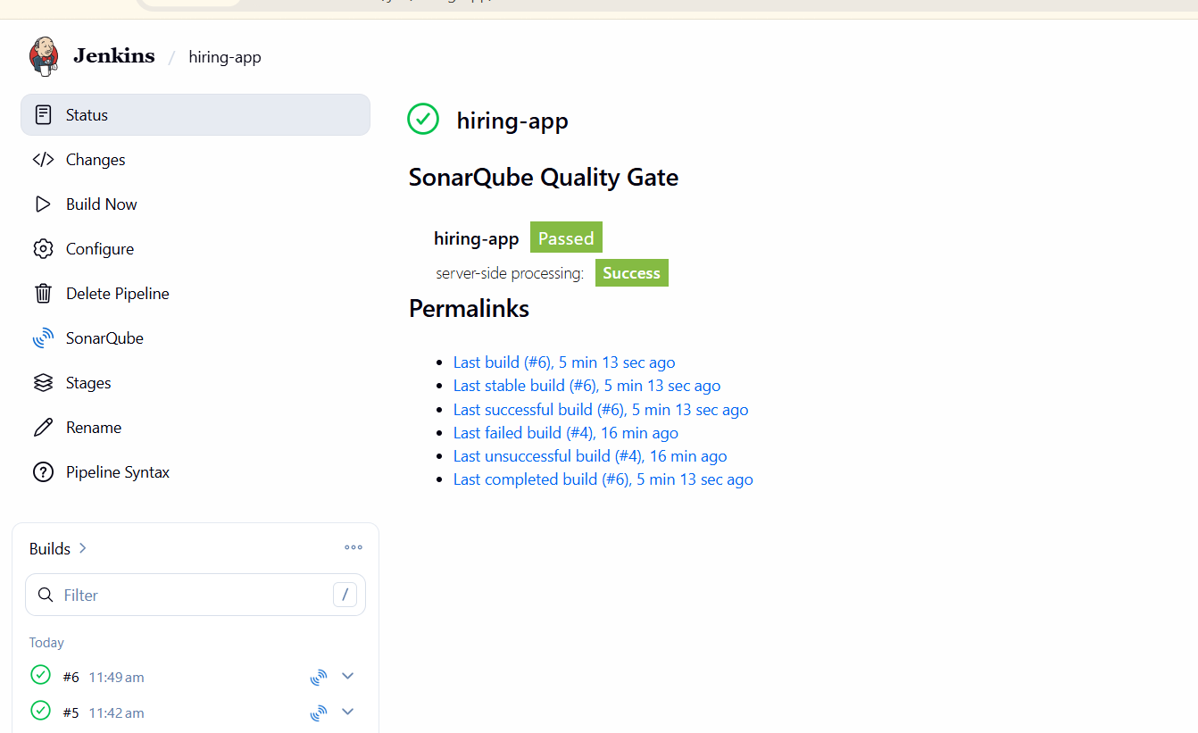
Build is triggered, after that check the consol output
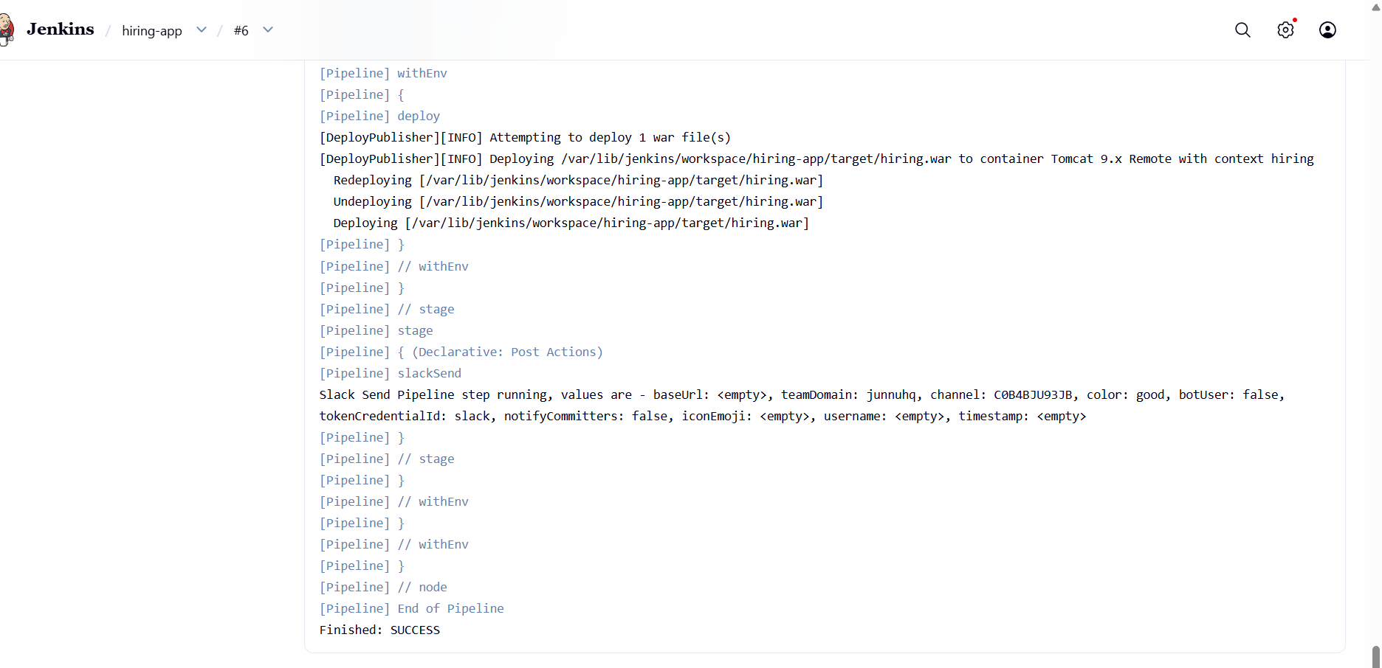
To build status send the slack app
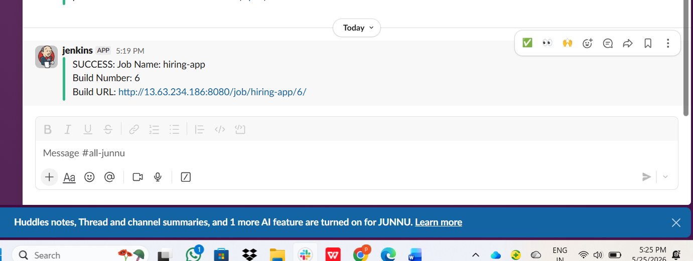

- Create one Scripted pipeline job

Open jenkins dashboard, select "New Item," and choose "Pipeline" as the project type.
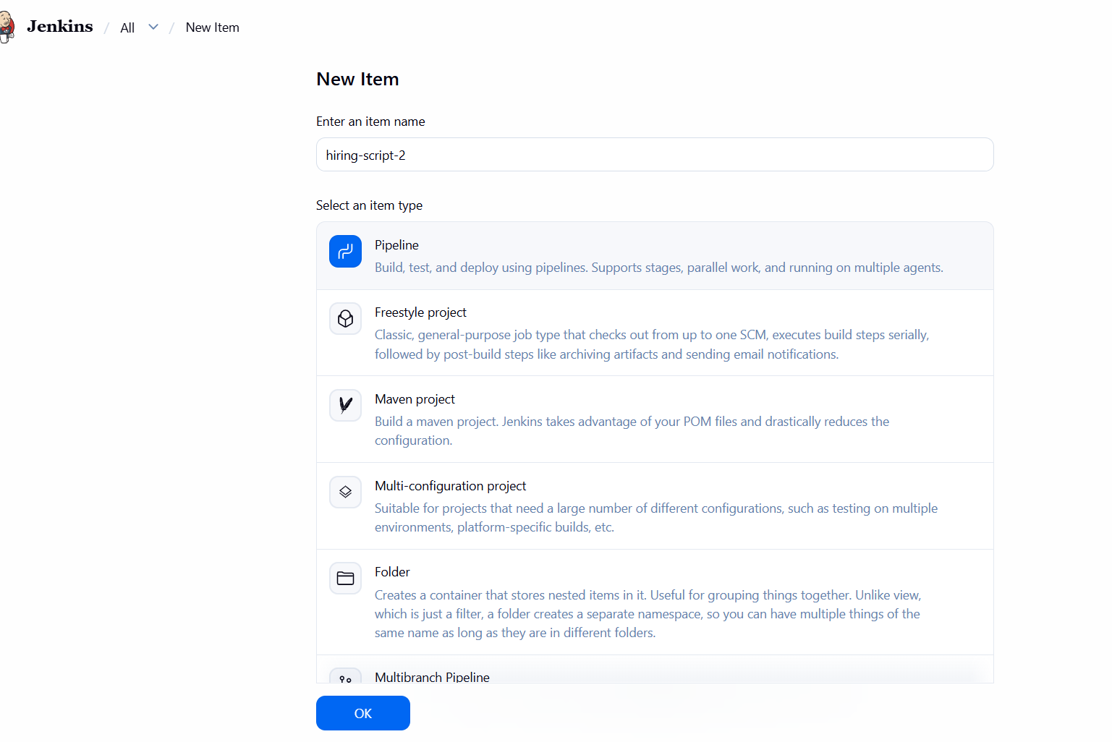
And go to the hiring-app-2---> click on configuretion --> scroll down to the pipeline section. Paste your Groovy script into the pipeline definition box,
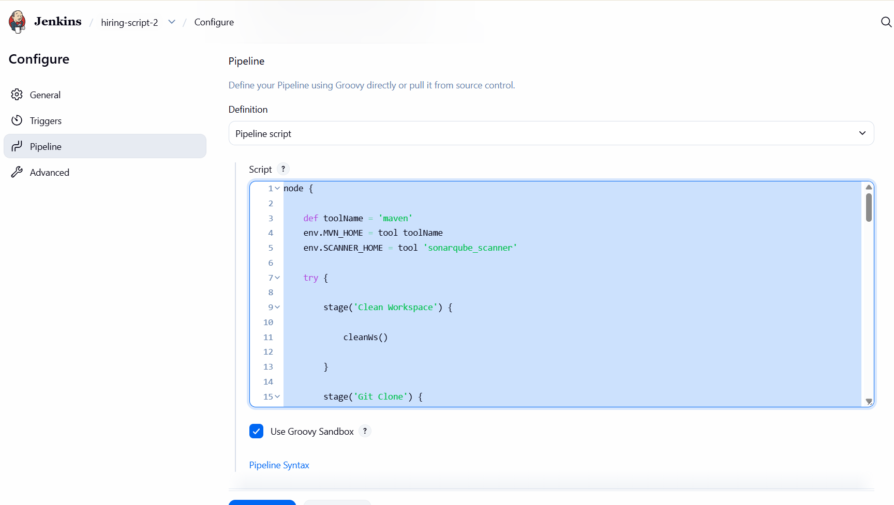
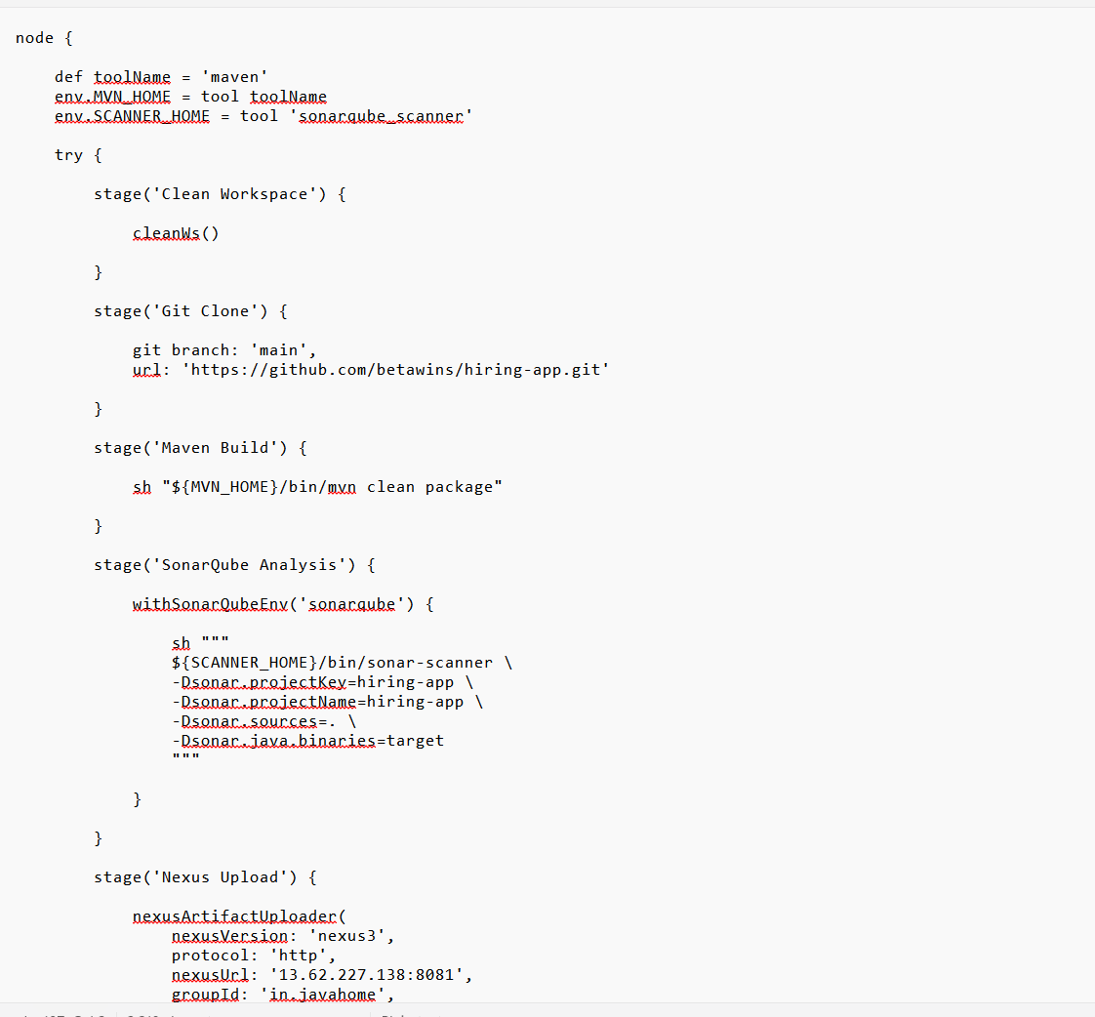
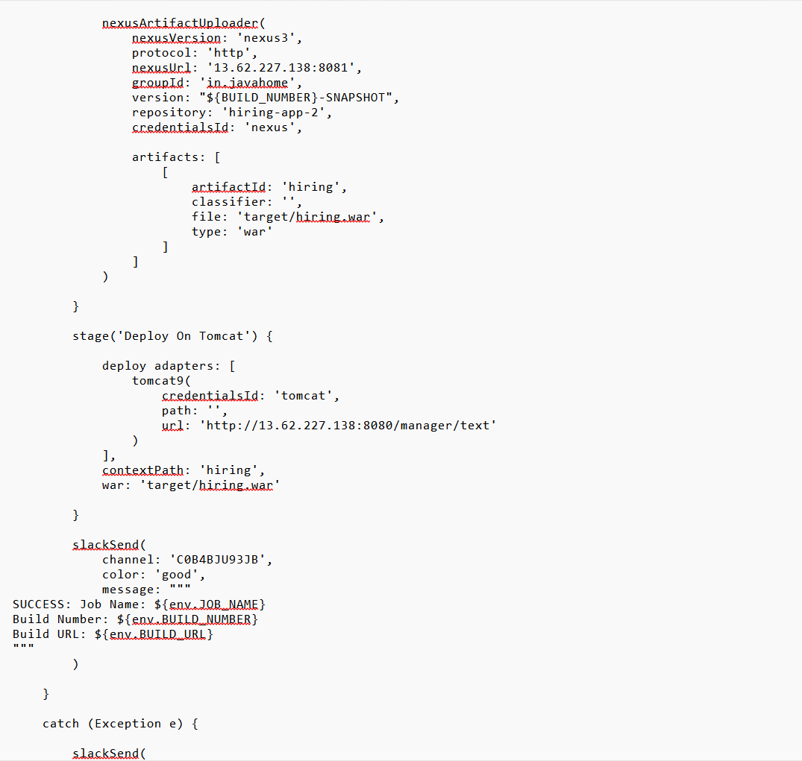
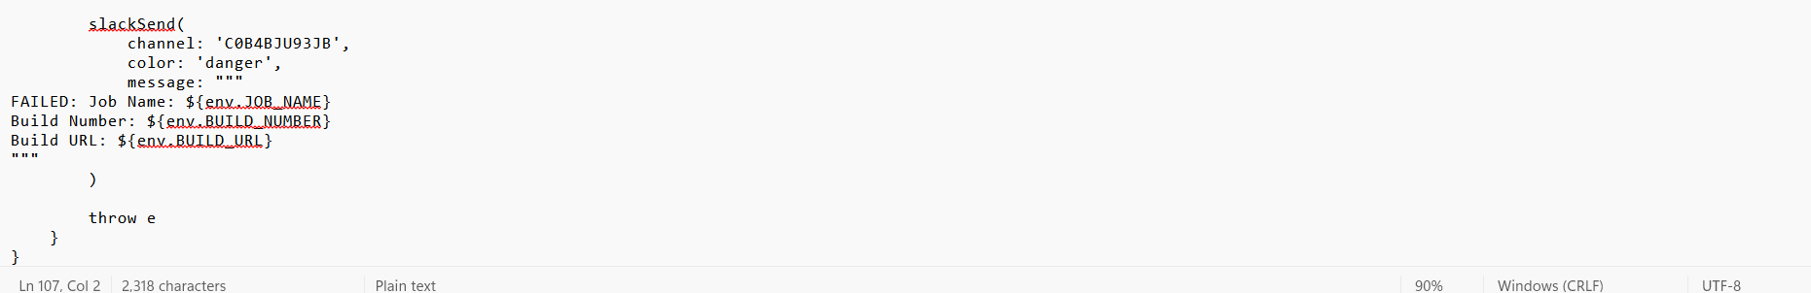
After that click on the "Save" button to finalize your configuration. Navigate back to the project dashboard and select "Build Now" to initiate the pipeline execution. Monitor the console output in real-time to track the progress of each stage, ensuring that the deployment process proceeds as expected and that the integration with the Slack notification system is functioning correctly.
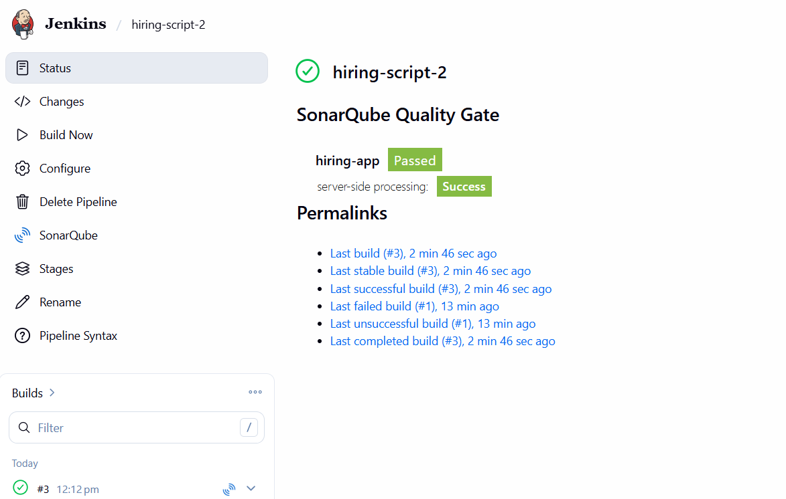
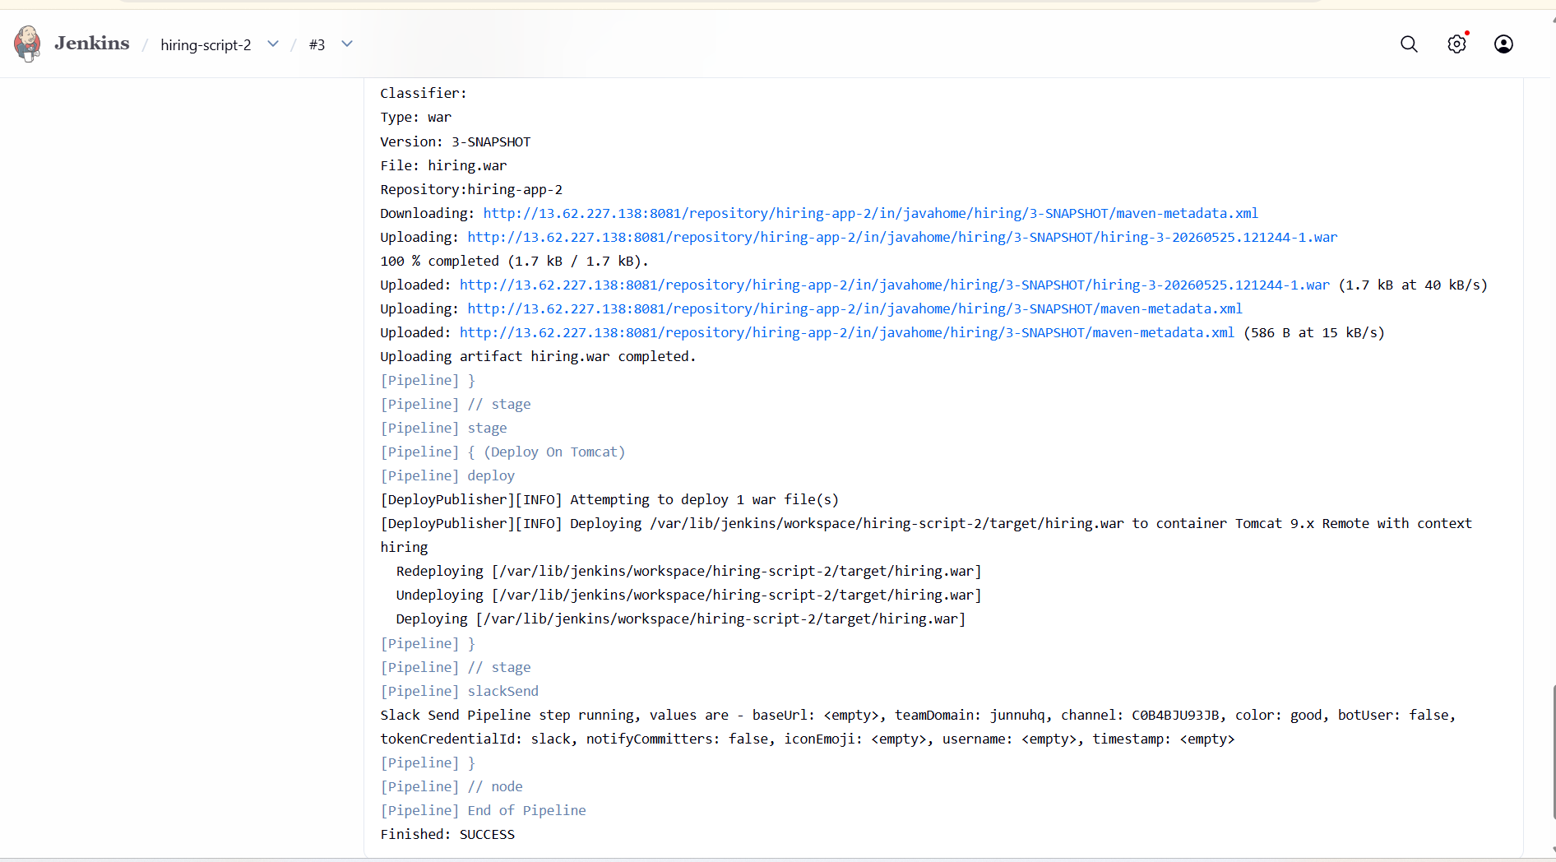

- Create one multi stage pipeline job
Open the Jenkins dashboard, select "New Item" and name it "Multi-Stage-Pipeline".select "Pipeline" as the project type, and click "OK".
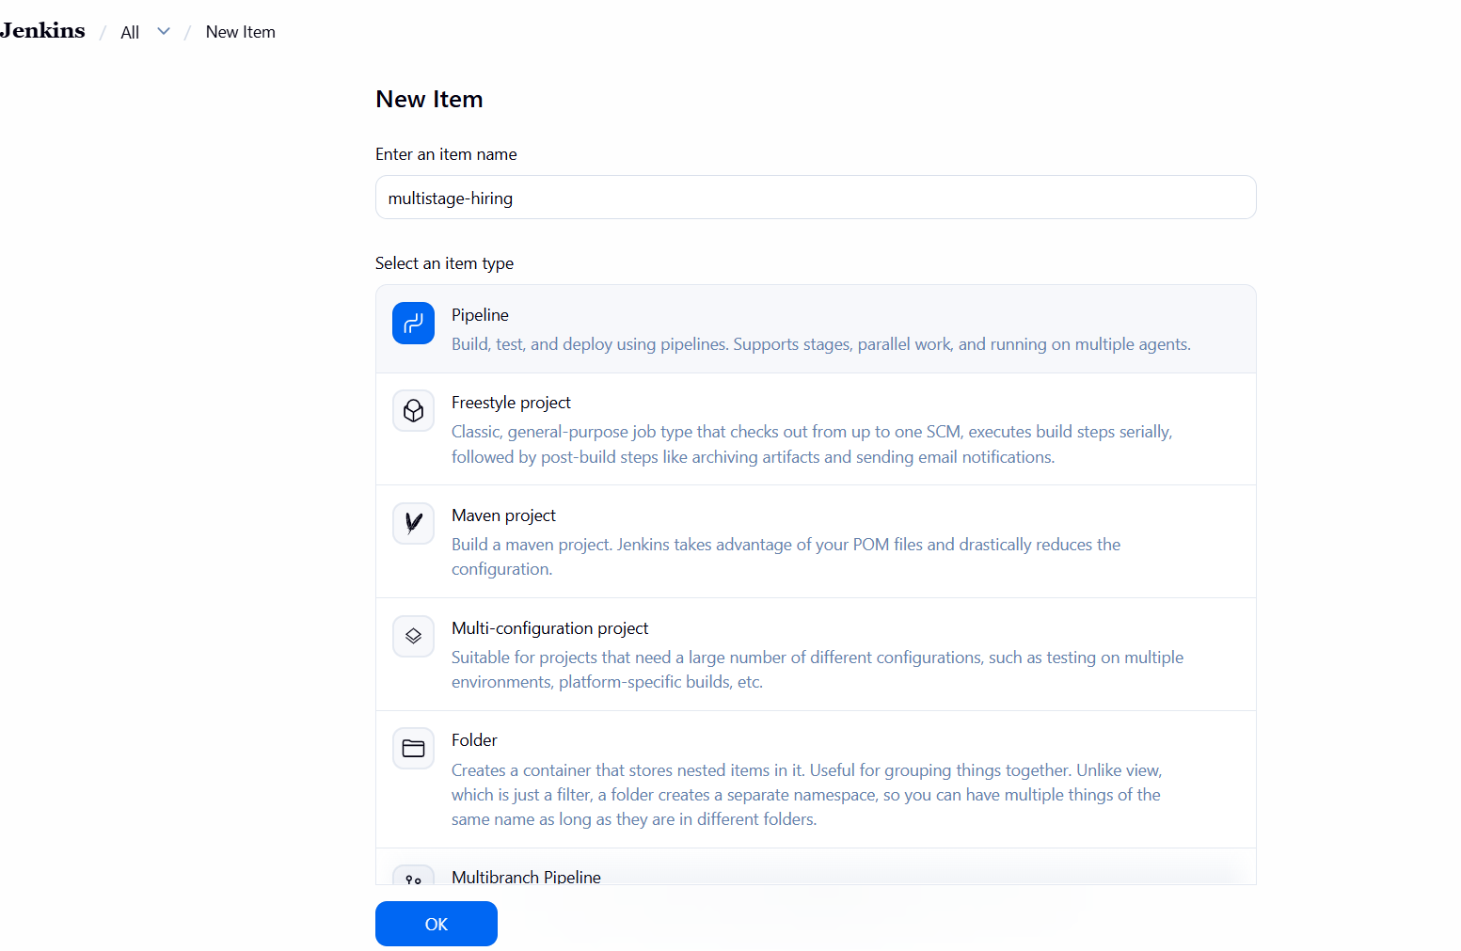
Once the configuration page loads, scroll down to the pipeline section. Paste your Groovy script into the pipeline definition box, ensuring that the syntax aligns with your project requirements. After that, click on the "Save" button to finalize your configuration. Navigate back to the project dashboard and select "Build Now" to initiate the pipeline execution,
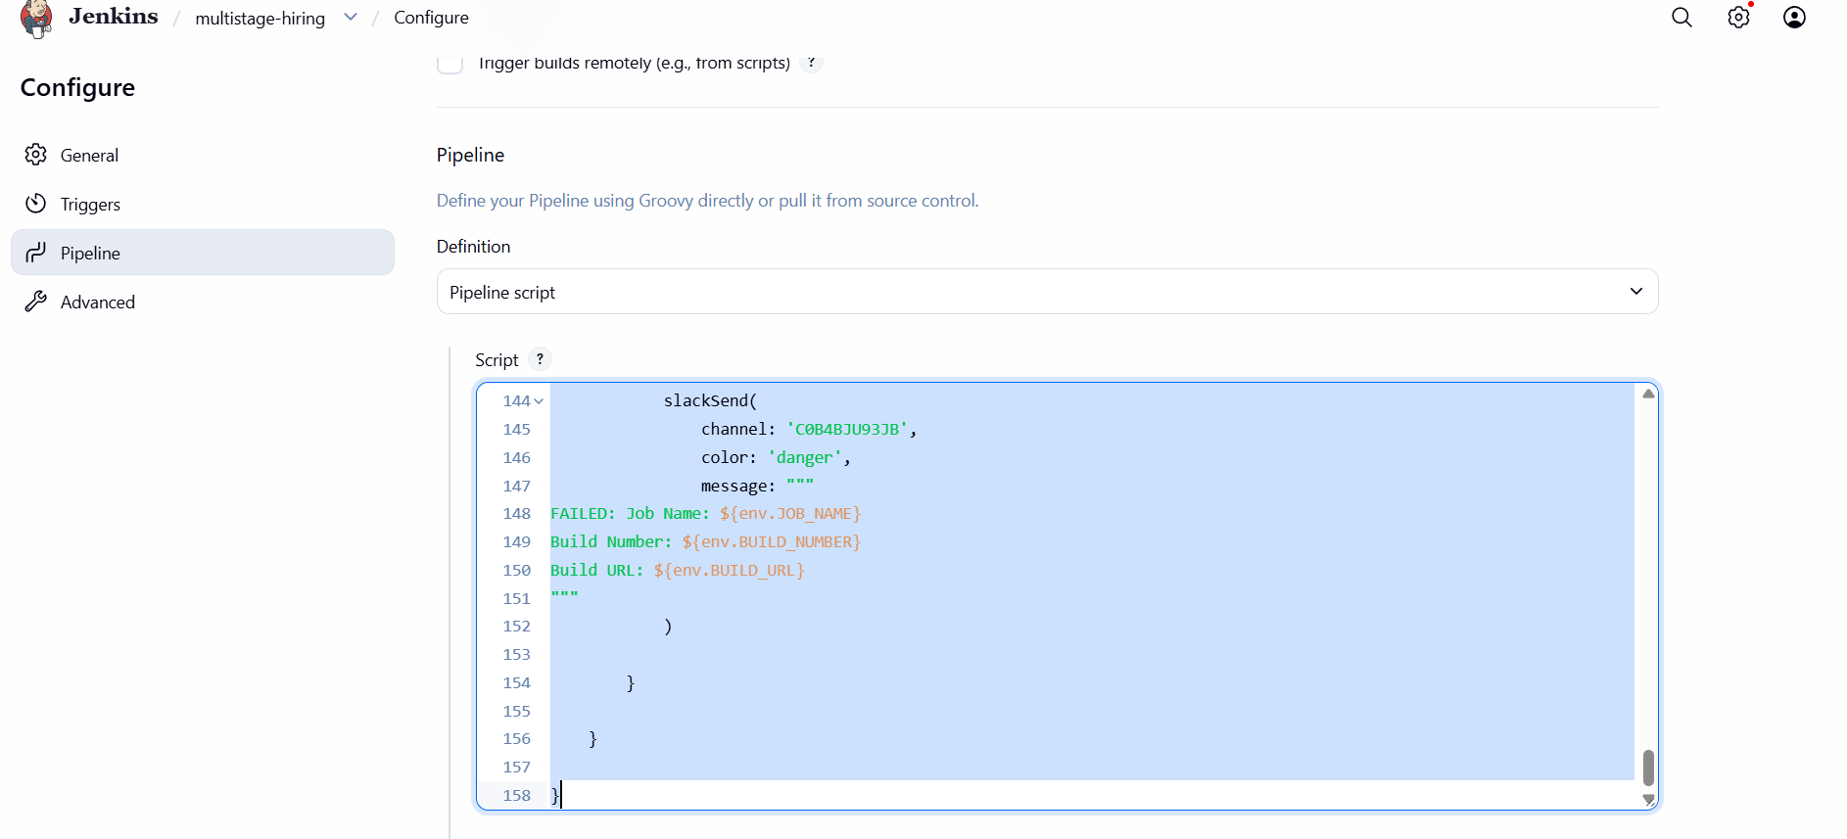
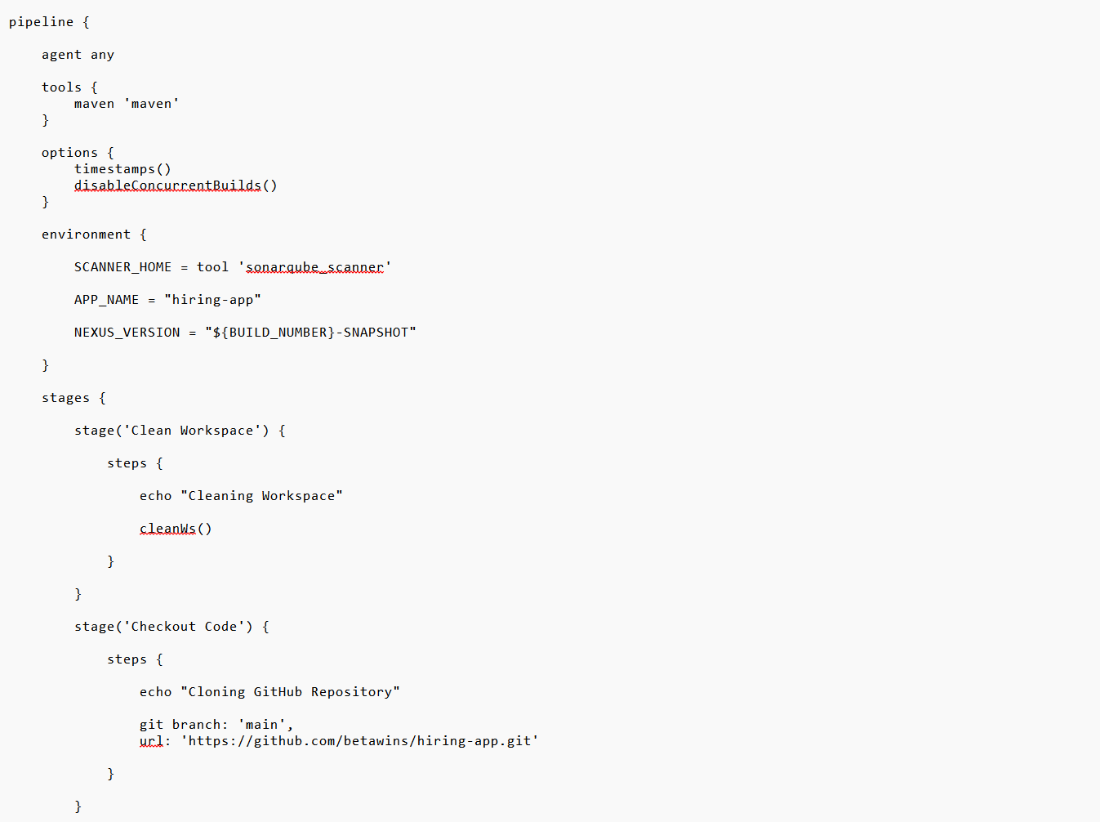
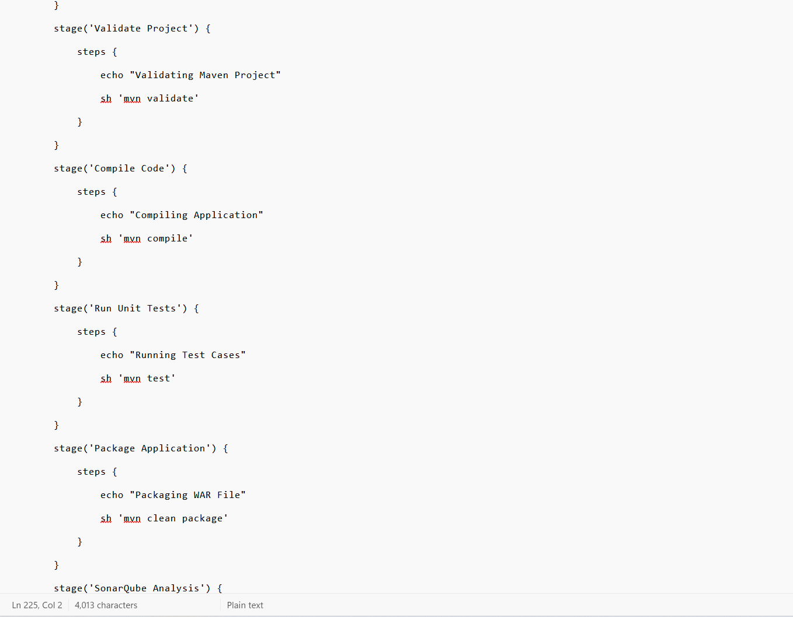
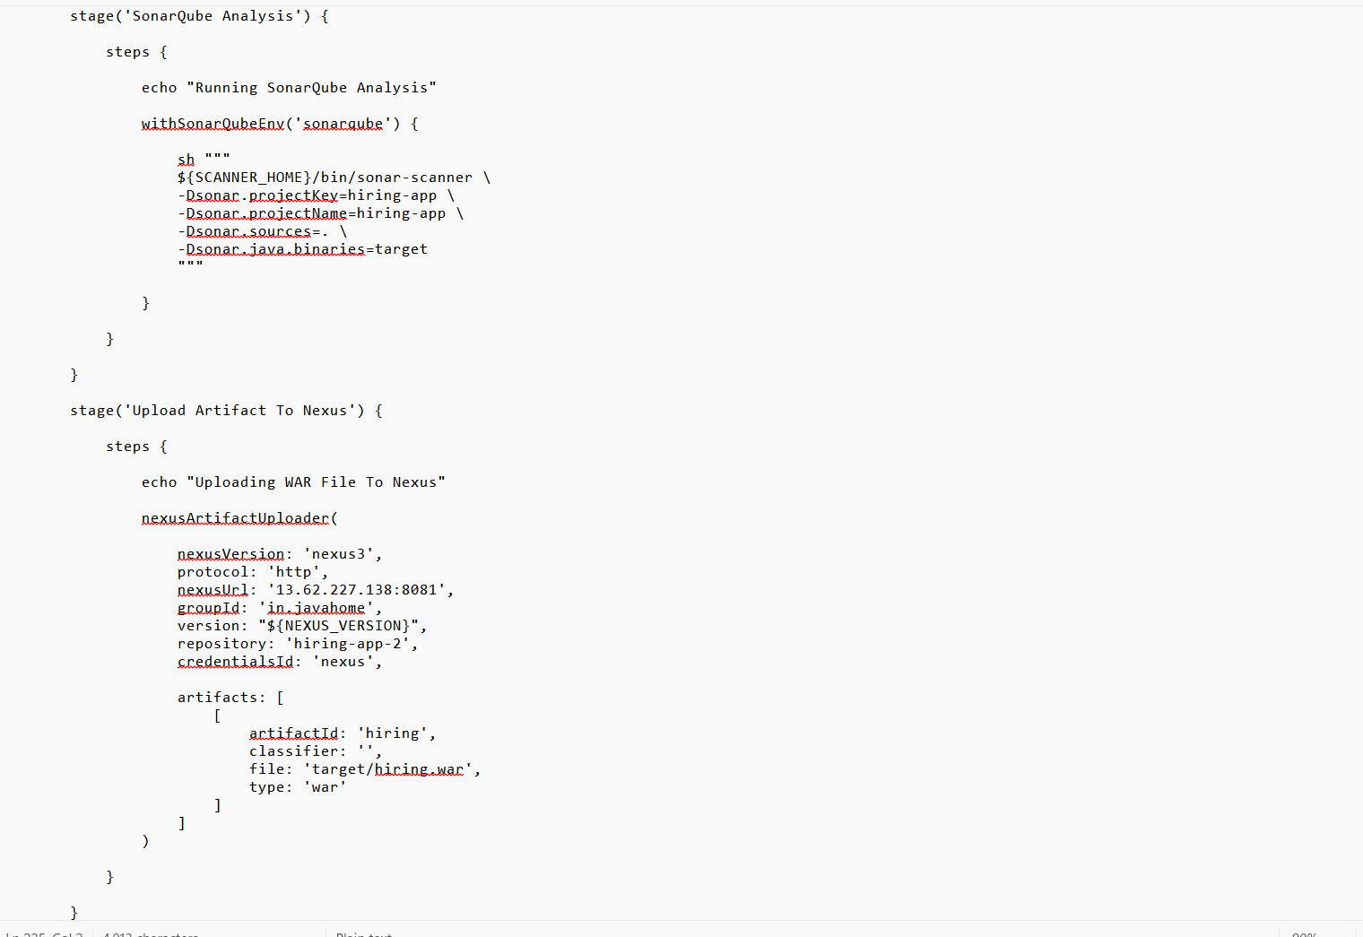
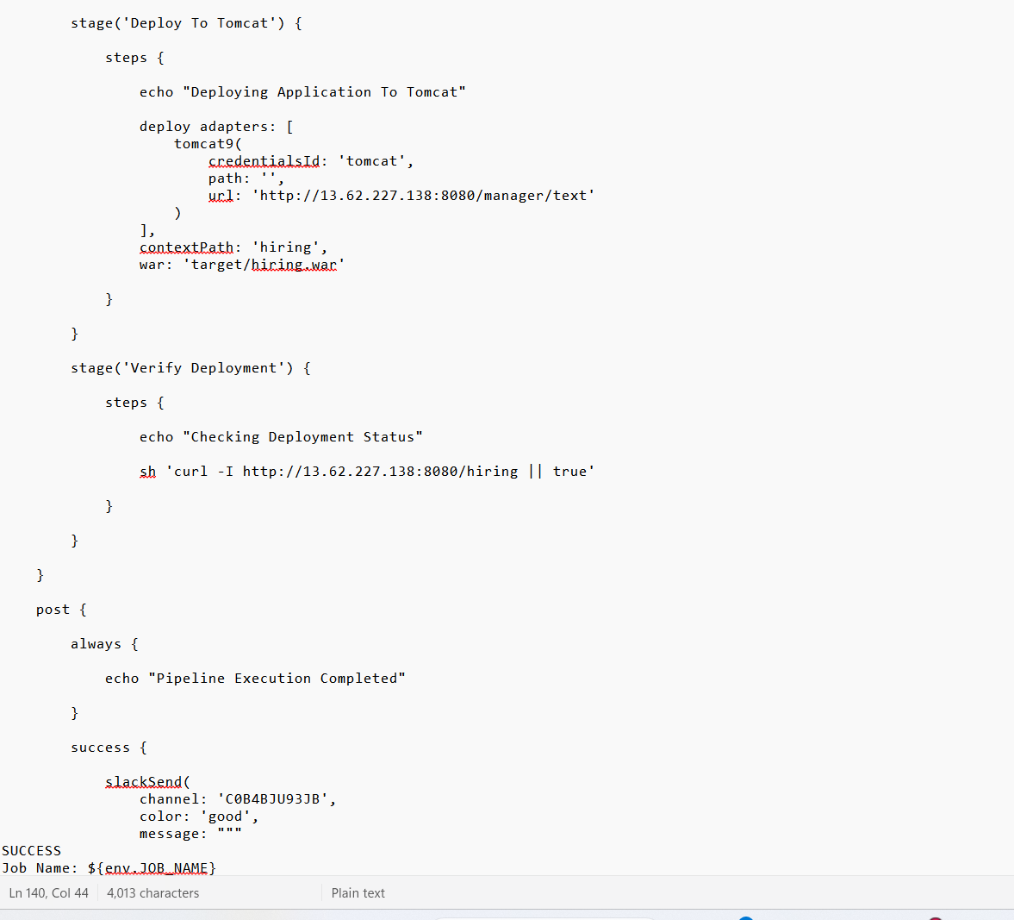
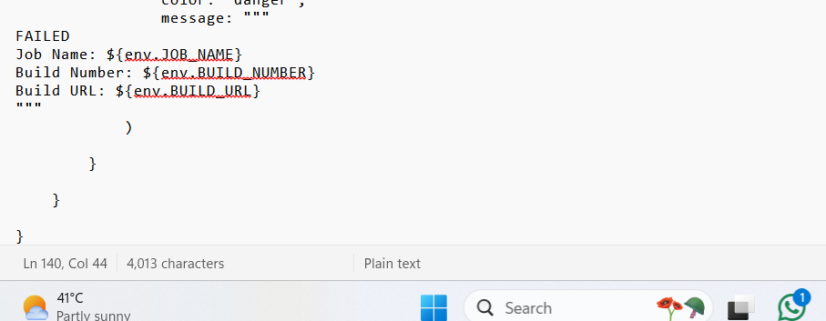
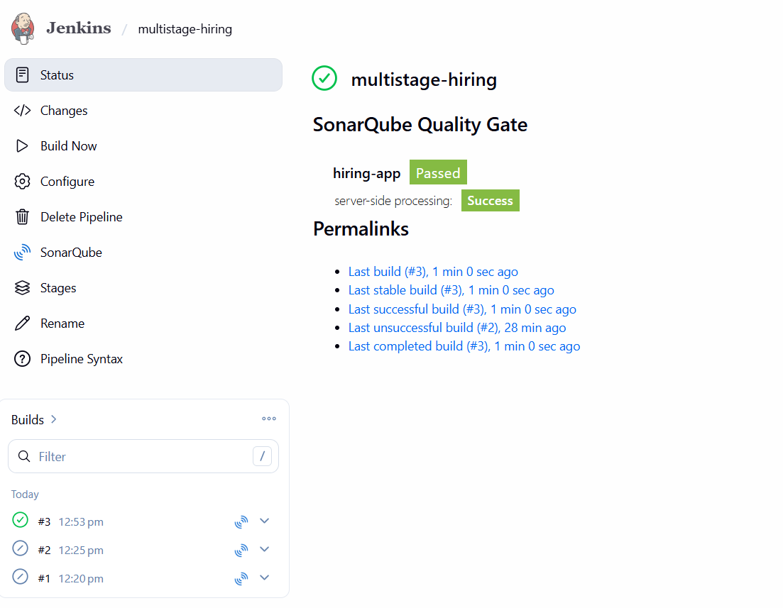
. Monitor the console output stage is successfully executing

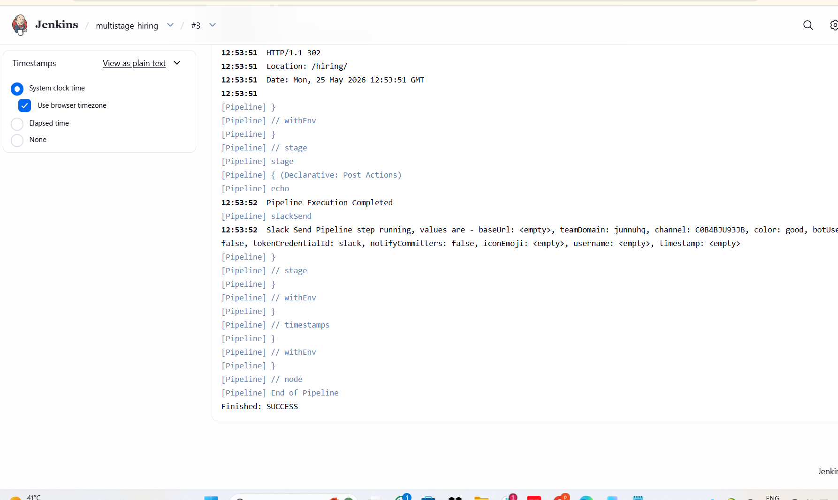
slacknotifications will provide real-time updates, allowing you to track each phase of the deployment process seamlessly.
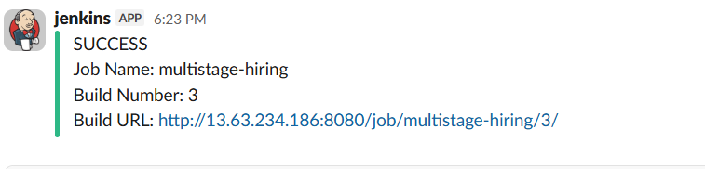

- Create one parallel stage pipeline job

Open jankins dashboard and select "New Item" to begin the setup. Enter a descriptive name for your project, choose "Pipeline" as the project type, and click "OK".
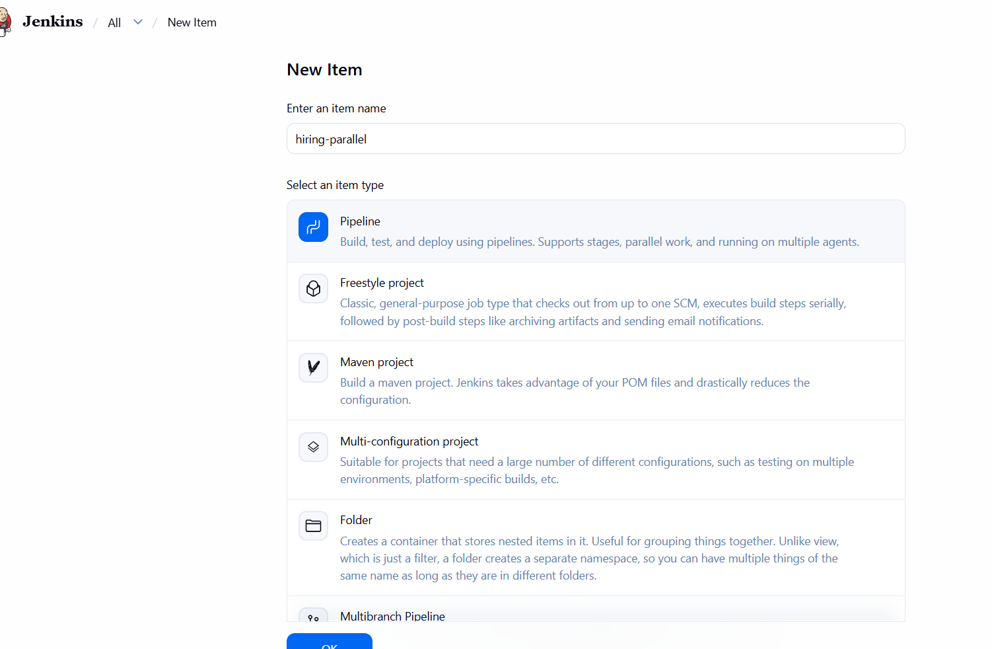
In the configuration section, scroll down to the "Pipeline" script area. Define your stages using the `parallel` keyword to execute multiple tasks simultaneously, such as running unit tests and code analysis in tandem.
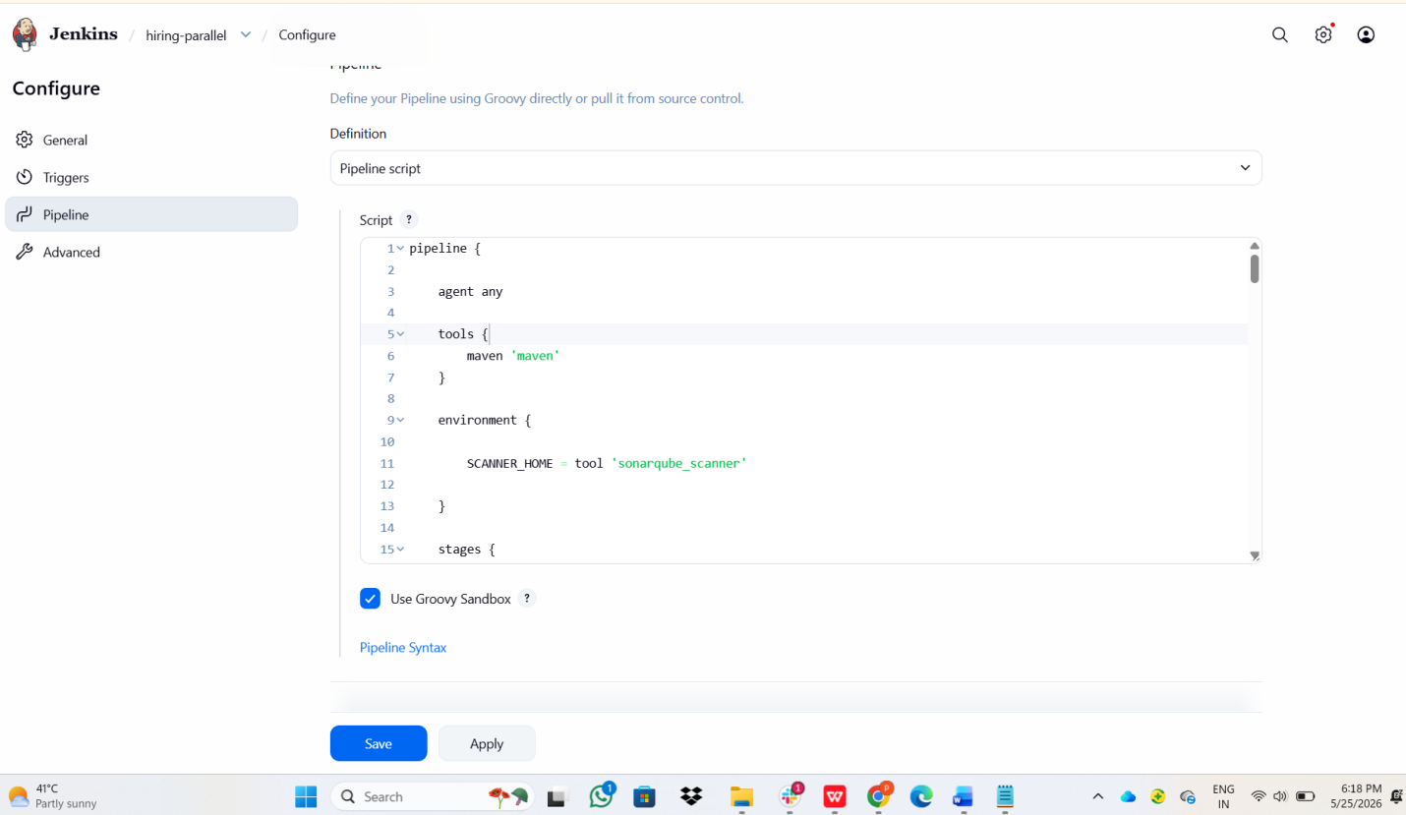
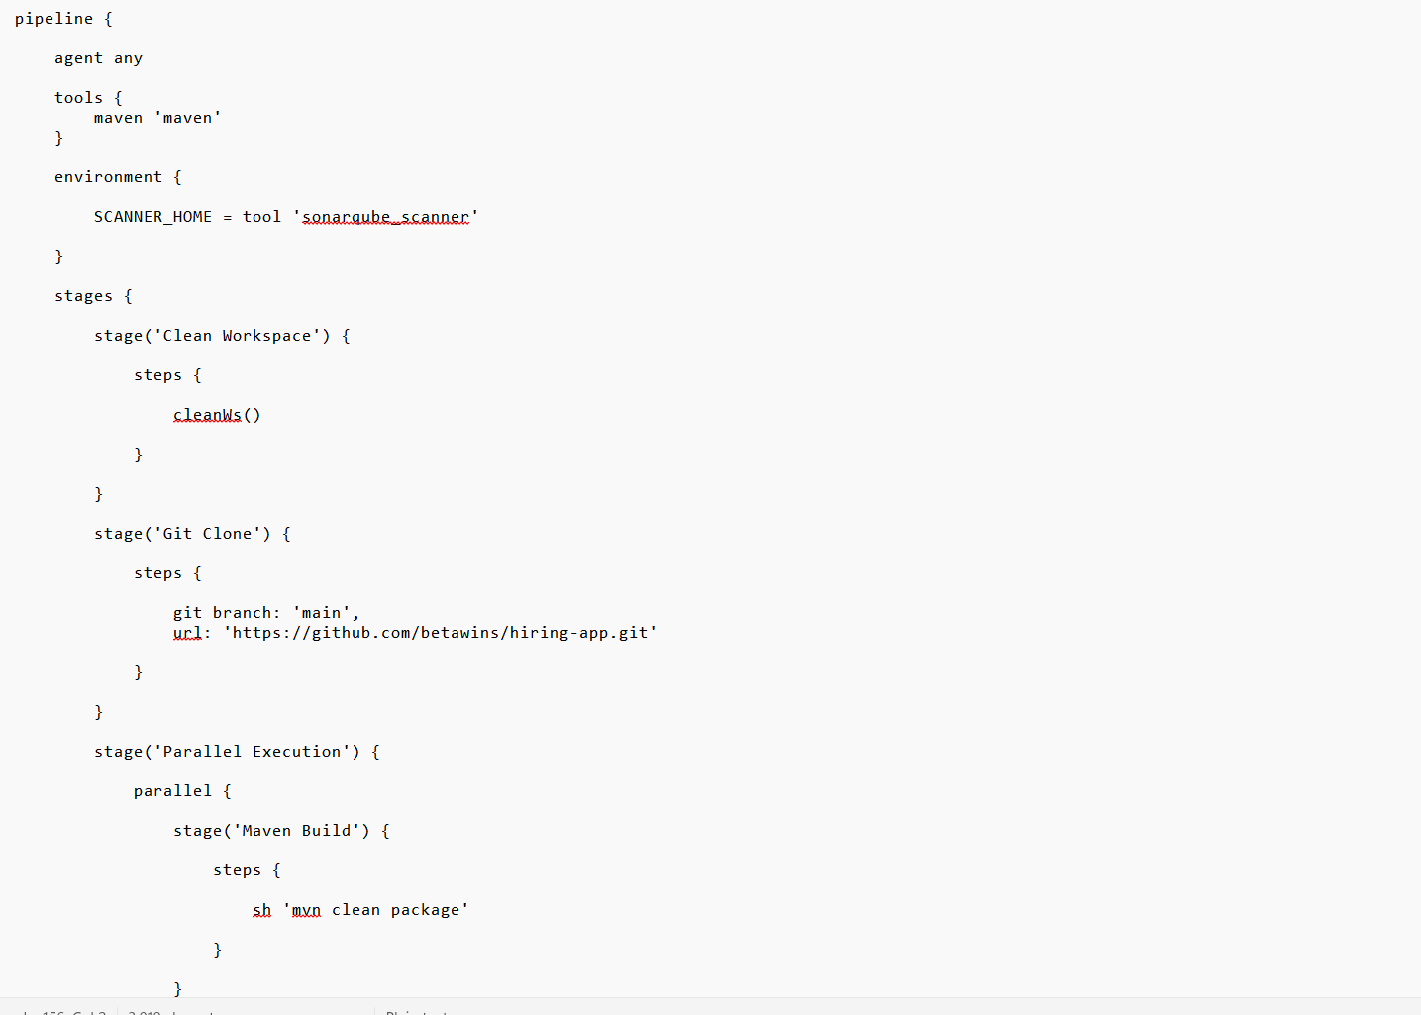
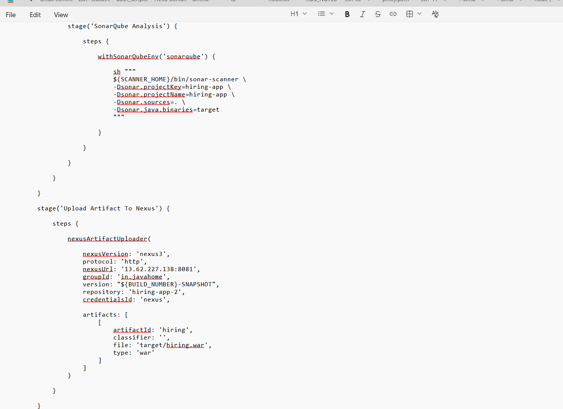
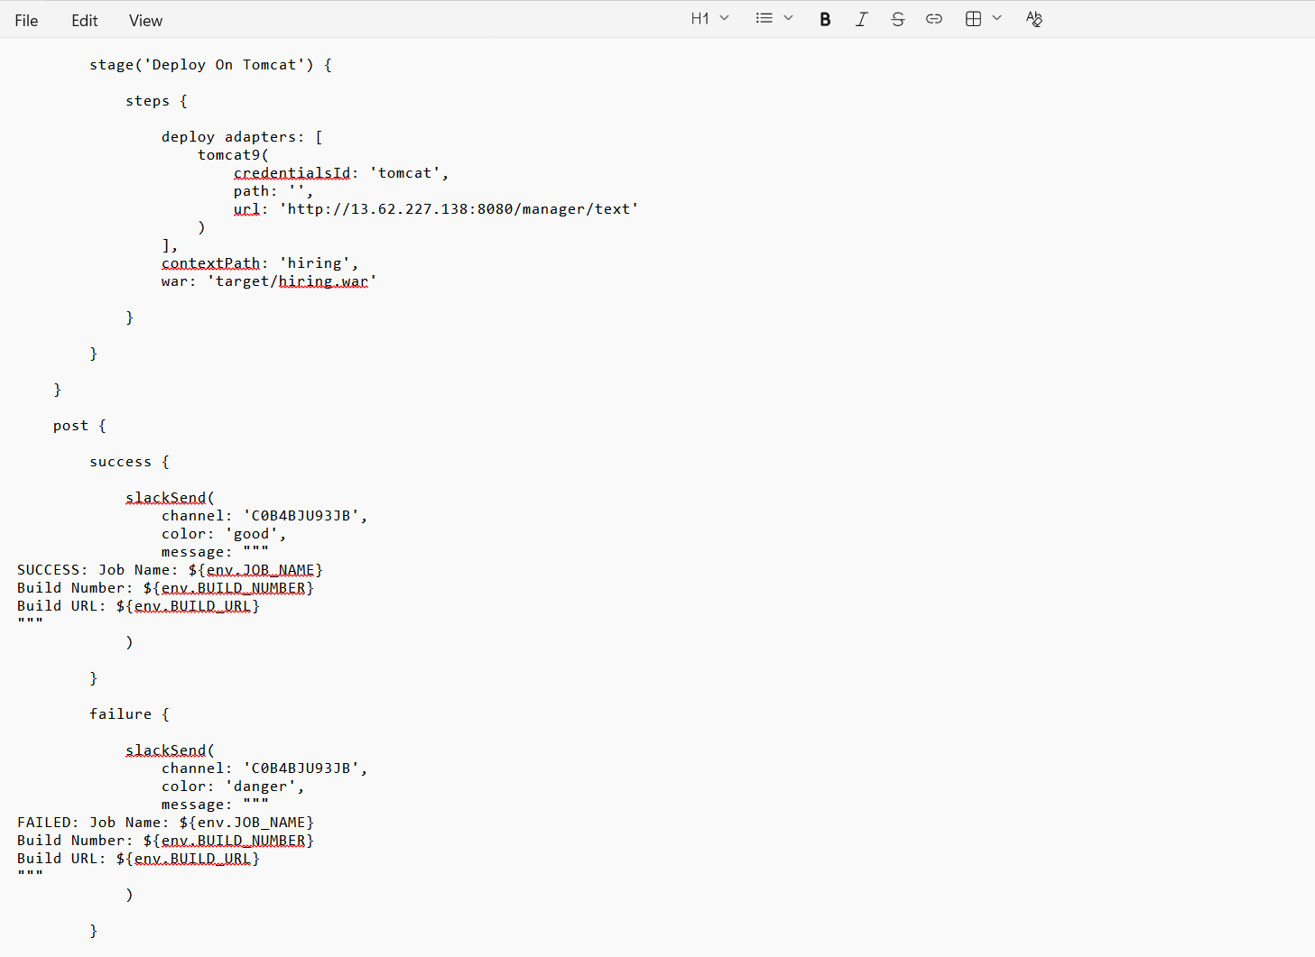
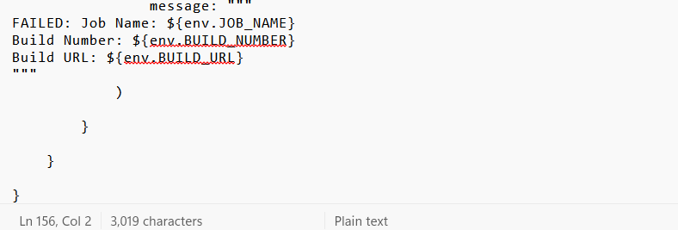
Save the script and click "Apply" to finalize your settings. Once saved go back to the project dashboard and click "Build Now" to trigger the pipeline.
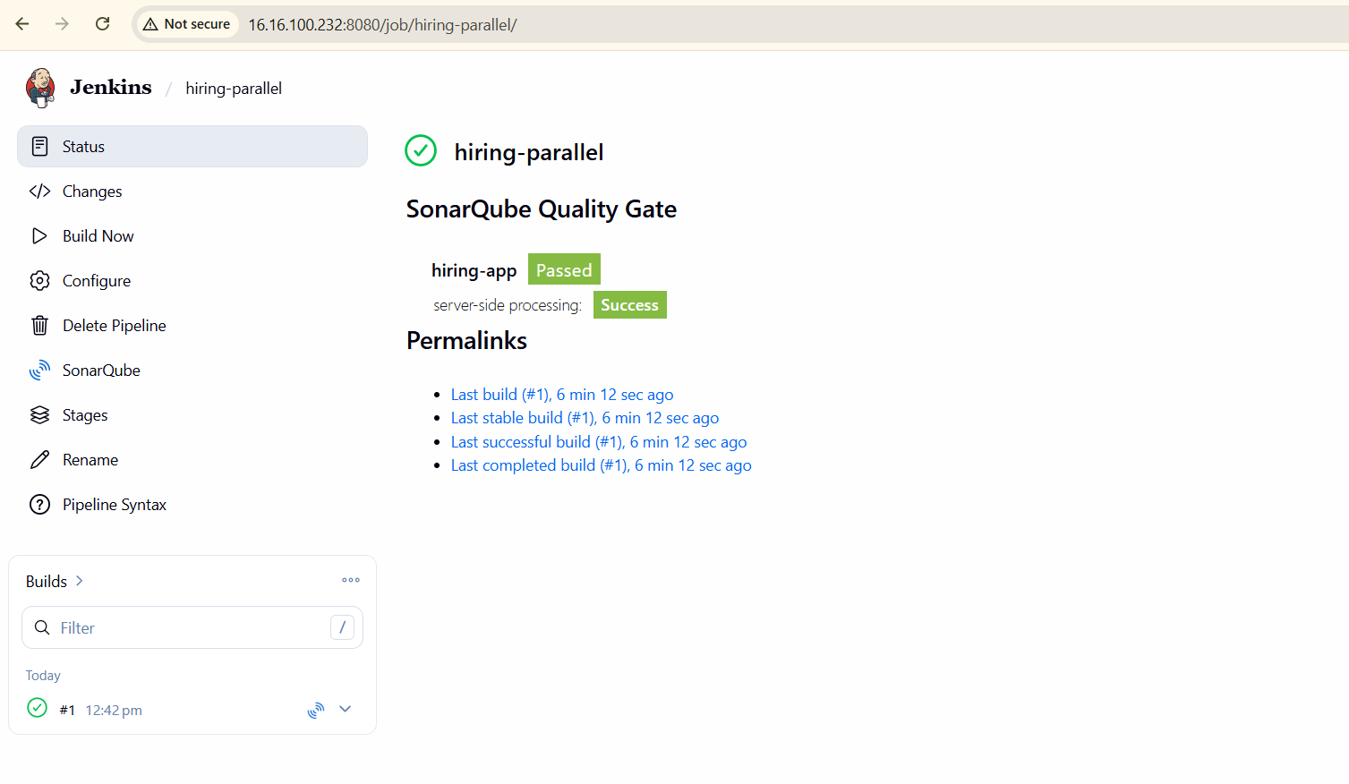
Monitor the console output to observe the parallel execution in real-time. You will see the logs for each stage appearing concurrently, confirming that your tasks are running efficiently. If any stage fails,
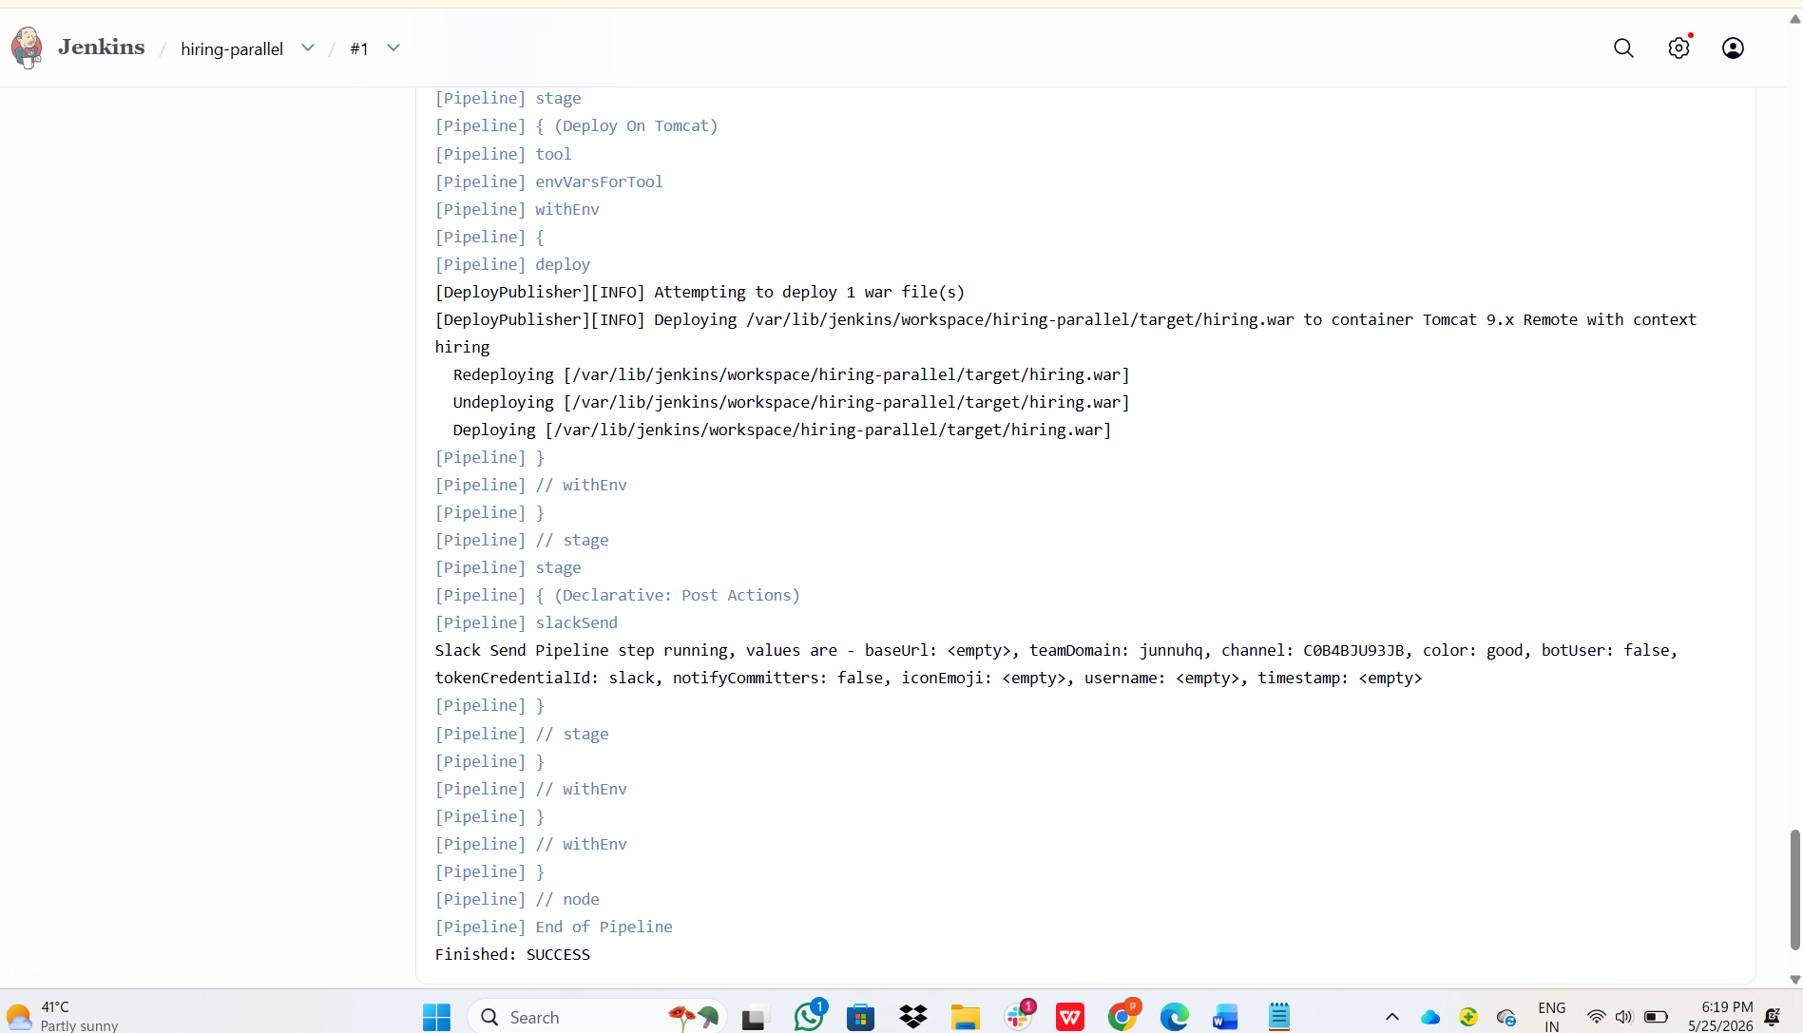
Slack notifications or email alerts will be triggered immediately,
